Title Page:
Analyzing of Data Utilisation in Medication-Reminder for A Comparative Study between Android and iOS Application.

Nisha. N1, Dr T Suresh Balakrishnan2
Nisha N¹
Research Scholar,
Department of Computer Science Engineering,
Saveetha School of Engineering,
Saveetha Institute of Medical and Technical Sciences,
Saveetha University, Chennai, Tamil Nadu, India. Pin code: 602105
192011495L.sse@saveetha.com

Dr T Suresh Balakrishnan²
Project Guide, Corresponding Author
Department of Computer Science Engineering,
Saveetha School of Engineering,
Saveetha Institute of Medical and Technical Sciences,
Saveetha University, Chennai, Tamil Nadu, India. Pin code: 602105
sureshbalakrishnant.sse@saveetha.com

Keywords: iOS Application, Android Application, Data Utilization, Medication-Reminder, Treatment, Research
ABSTRACT:

Aim: The objective of this project is to evaluate and compare the navigation Data Utilization and user navigation durations encountered during the treatment procedure on both the Medication-Reminder Android application and the iOS platform. Materials and Methods: To enhance the evaluation of Data Utilization in treatment procedures, an Android application (N=10) and an iOS application (N=10) will be employed for text summarization. Gpower analysis will be utilized with 80% power to ascertain the suitable sample size. Result: The evaluation of treatment on the Android application shows a Data Utilization of 33.83 Mb, whereas the iOS application outperforms it with a Data Utilization of 28.17 Mb. Statistical analysis reveals a notable distinction between the Android and iOS platforms, supported by a p-value of 0.005 (p < 0.05). Conclusion: Displaying a Data Utilization of 28.17 mb, the iOS application surpasses the Android application, which exhibits a Data Utilization of 33.83 mb. This highlights a performance discrepancy between the two platforms.

Keywords: iOS Application, Android Application, Data Utilization, Medication-Reminder, Treatment, Research

INTRODUCTION:

This research undertakes a quantitative examination of the navigation time between the Medication-Reminder iOS and Android applications within the treatment process (Ahmed et al. 2018). Employing robust metrics, the study discerns variances in user experiences and system performance between the two platforms, providing developers with opportunities to iteratively enhance interfaces, thus enhancing user satisfaction (Chew, Lai, and Ng 2020). These findings enable organizations to make informed decisions about treatment-related activities, promoting maximal participation through the utilization of Medication-Reminder. Ultimately, our study contributes valuable insights to the broader conversation on digital user experience, aiding in the enhancement of online application design to facilitate seamless interaction with medical platforms (Son et al. 2010). Through meticulous examination of time durations for various actions and processes within the app, encompassing loading screens, feature accessibility, and command execution, we aim to furnish a thorough overview of its responsiveness (Al-Arkee et al. 2021).

Within the expansive realm of Medication-Reminder research, a plethora of scholarly literature is accessible via reputable platforms such as the IEEE Xplore digital repository, housing (1,679 journals). Additionally, the Science Direct website grants access to a considerable collection of (1,34,230 articles), while the Google Scholar database hosts an extensive repository comprising (1,770,356 articles). Furthermore, Springer Publishers augment the wealth of available literature with (5,876 articles). In this paper, we comprehensively explore performance metrics about Data Utilization in the Medication-Reminder application. Through meticulous examination of time durations for various actions and processes within the app, encompassing loading screens, feature accessibility, and command execution, we aim to furnish a thorough overview of its responsiveness (Wiecek et al. 2020). Furthermore, our objective is to pinpoint potential bottlenecks or inefficiencies that could impede user experience and productivity. By conducting a detailed performance analysis, we aim to provide actionable recommendations for optimizing the Medication-Reminder application to ensure seamless functionality and enhance user satisfaction (Ali et al. 2017). Moreover, this study will contribute valuable insights to the broader discourse on mobile application performance evaluation, carrying implications for improving the usability and efficacy of orthopedic assistance tools such as Medication-Reminder (McBride, Morrissey, and Molloy 2020). Recognizing the significance of prompt responses in orthopedic support applications, we undertake a systematic inquiry to evaluate the effectiveness of the Medication-Reminder platform (Pérez-Jover et al. 2019). Ultimately, our discoveries will enlighten developers and stakeholders about opportunities for enhancement and optimization to elevate user experience and contentment. By cultivating a more profound comprehension of Data Utilization dynamics, this research aids in the progression of mobile health technology and orthopedic care.
Assessing the efficacy of online applications holds paramount importance in technology-driven philanthropy, ensuring streamlined and user-friendly contribution processes. This investigation focuses on comparing navigation Data Utilization between the Medication-Reminder iOS platform and its Android counterpart throughout the contribution process (Shah et al. 2016). By delving into the intricate facets of digital philanthropy, this research aims to illuminate user engagement dynamics specific to treatment transactions, addressing a notable gap in the current literature (Pouls et al. 2021). With a multidisciplinary research team comprising experts in usability, philanthropy, and human-computer interaction, the study is positioned to offer comprehensive insights. The ultimate objective is to enhance user experiences in the digital treatment context by providing empirical data on the performance of the Medication-Reminder Android application and iOS platform during treatment procedures (Tran et al. 2022).

Materials & Methods:

The study is conducted at the Ideation Laboratory within the Computer Science and Engineering department of the Saveetha School of Engineering, affiliated with the broader Saveetha Institute of Medical and Technical Sciences, this study adopts a structured approach involving two distinct groups (Kosse et al. 2019). Group 1 focuses on exploring the intricacies of the Android application, while Group 2 delves into the realm of the iOS application. Employing a robust methodology, the research sets the G-power at a robust 80% and utilizes the Clincalc Website's analytical power to estimate the optimal iteration sample size (Dayer et al. 2017). Through meticulous calculation, the study determines an appropriate number of iterations, set at 10 for each group, resulting in a total sample size of 20.

XAMPP is a software program designed to streamline the process of establishing a local web server environment on a PC, making it efficient and straightforward. It simplifies the creation and configuration of essential Android development components, allowing users to install and operate a fully functional web server on their computers. The acronym "XAMPP" denotes its key components: Apache, MariaDB (formerly MySQL), PHP, and Perl. Primarily used for facilitating the development and testing of websites and Android applications in a controlled local environment before deployment to a live server, XAMPP eliminates the need for users to install and manage individual components such as web servers, database servers, and programming languages. By enabling developers to swiftly set up a local server environment that closely resembles a production server's setup, XAMPP facilitates testing the functionality and interoperability of Android applications without requiring an internet connection. Particularly advantageous for developers working with PHP and MySQL, as these components are included in the XAMPP package, it is a reliable and user-friendly solution for simplifying the setup of a local web server. This streamlined process aids developers in focusing more time on building and refining their Android projects in a secure environment on their personal computers. Overall, XAMPP is a valuable tool for Android developers due to its quick and easy setup process for local server development and testing.

The iOS application's architecture incorporates a specialized API that facilitates seamless connectivity with the XAMPP server. Utilizing the Swift programming language, the application effectively coordinates and accesses this API. Typically, HTTP POST requests are employed to communicate with specific API endpoints, which then trigger corresponding PHP scripts on the server. These PHP scripts serve as API handlers, retrieving relevant data from the database and encapsulating it in the widely used JSON format before transmitting it back to the iOS application. This systematic approach enhances the efficiency and effectiveness of data transfer between the application and the server. Embedded PHP code within the Android application governs the connection to the XAMPP server, with PHP scripts playing a pivotal role in establishing communication with the server's MySQL database. Simplified access and manipulation of data stored in the database are facilitated by PHP scripts, which execute SQL queries within this connection framework. This intricate process ensures seamless interaction between the Android application and the MySQL database hosted on the XAMPP server. PHP scripts serve as versatile intermediaries, facilitating dynamic engagement with the database through SQL queries to address the evolving data requirements of the Android application.

iOS application

The goal of this project is to improve the system to provide users with a smoother and more responsive experience. The iOS application serves as a benchmark for Group 1's preparations, focusing on reducing navigation delays and Data Utilization during the treatment and medical request processes within the Medication-Reminder iOS application. The objective is to minimize delays and ensure prompt communication through strategic enhancements and refined procedures, thereby boosting the overall efficiency of the application for treatment within the dynamic medication reminder environment. Table 1 provides further insights by presenting the pseudocode of the iOS Application and encapsulating the central processing unit.

Android application

In our pursuit of delivering an improved and more responsive experience for consumers, our focus lies in enhancing the system architecture. The Android application serves as a preparation example for Group 2, aiming to address issues concerning Data Utilization and navigation latency during treatment procedures within the Medication-Reminder Android application. This entails optimizing data, making modifications on the server side, and implementing efficient algorithms. By carefully adjusting these parameters, our goal is to reduce latency and improve real-time updates, thereby facilitating seamless and enjoyable user interaction with the application. Furthermore, by incorporating user feedback and conducting iterative testing, essential components of the continuous development process, we can customize the speed of the Android application to meet the evolving needs of medication reminder enthusiasts. Table 2 provides the pseudocode for the Android Application.

Statistical Analysis

IBM SPSS is recognized as a valuable research tool for categorizing statistical data across diverse industrial sectors. It provides a variety of commonly utilized computations, such as mean, F-value, degrees of freedom (df), and standard error, which are fundamental for assessing significance (Davies et al. 2015). The main goals of employing SPSS involve calculating Data Utilization and extracting resource allocation data from the dataset, which are essential for comprehending and resolving delays in the Medication-Reminder application's Data Utilization during real-time navigation in treatment procedures.

RESULTS

Table. 1 The provided procedure offers a systematic method for monitoring data usage within the Xcode "Medication-Reminder" application. By following these steps, users can efficiently observe and analyze network activity to understand data Utilization patterns.

Table. 2 The guidelines provided present a structured approach for monitoring data usage within an Android application using browser developer tools, offering step-by-step instructions.

Table. 3 It is noted that text data has been submitted with a sample size of N = 10. Data Utilization rates for developing iOS and Android apps are computed every ten iterations. Regarding accuracy, the iOS application demonstrates superior performance compared to the Android application.

Table. 4 This entails a comparison of data from independent samples utilizing the Android Development Algorithm and iOS. The average Data Utilization for Android development is 33.83, whereas for iOS development, it stands at 28.17. The relative standard deviations for iOS and Android development are 4.648 and 4.303, respectively. Android Development has a standard error mean of 1.343, while iOS exhibits a mean of 1.202.

Table. 5 The comparison between iOS and the Android Development Algorithm is conducted using a 95% confidence interval in statistically independent samples, employing a T-Test. The results reveal a statistically significant distinction between the Android Development algorithm and the iOS algorithm, with a p-value of 0.005 (p<0.05).

Fig. 1 displays the patient questionnaires screen of the Medication-Reminder application from patient login where the patient will have to answer the question provided so that the doctor will be able to analyze the health status of the patient with the help of points achieved from the questionnaires.

Fig. 2 The comparison indicates that the mean Data Utilization for the iOS algorithm is 28.17, whereas for the Android Development method, it is 33.83. The Y-axis represents the mean Data Utilization, while the X-axis illustrates the comparison between iOS and Android Development approaches, with error bars extending to ±2 standard deviations.

Fig. 3 shows the database table of Medication-Reminder related to the patient details such as patient ID, patient password, patient name, patient contact, patient age, patient gender, patient height, patient weight, date of surgery, patient mail, and patient result of the quiz. These details help doctors to know about the patient and his status of health.

DISCUSSION

The significance value is derived from the results of an independent sample T-test analysis. In summary, the iOS application demonstrates faster performance by 28.17 mb compared to the Android application, which operates at 33.83 mb slower. The calculated significance level is 0.005, indicating a value smaller than 0.05.

This study delves into the vital doctor-patient relationship, investigating Data Utilization in treatment procedures through iOS and Android Applications. It emphasizes the importance of prompt responses and explores how real-time monitoring offered by Android and iOS platforms enhances user experience (Park et al. 2019). The study underscores the significance of technological solutions like efficient algorithms and data optimization in addressing navigation delays and enhancing system architecture (Nkhoma et al. 2021). Furthermore, it elucidates the iterative processes of continuous testing and user feedback within the Medication-Reminder framework (Roosan et al. 2020). Discussions predominantly revolve around improving Data Utilization, enhancing user interfaces, and strategically utilizing technology to improve the effectiveness of Medication-Reminder's treatment procedures (Babel et al. 2021). The research underscores the iterative nature of the Medication-Reminder platform's user feedback process, highlighting ongoing testing and enhancement to better align with user experiences and preferences (Ehrler et al. 2018). This iterative approach not only showcases the platform's adaptability to user demands but also serves as a deliberate strategy to maximize Medication-Reminder's overall effectiveness (Islam et al. 2022).

The project's success hinges on several essential elements operating in synergy to advance its goals. Sufficient financial, human, and technological resources are vital for progress. Clearly outlined targets and timelines, along with effective planning and execution, are essential for steering the project towards its intended outcomes. Active involvement and fostering open communication are crucial for establishing shared understanding and commitment to project objectives. Effective risk management strategies, including identifying and addressing obstacles, are necessary for achieving goals. Selecting and utilizing appropriate technology and tools are critical for ensuring project efficiency. Projects with legal implications must comply with all relevant laws and regulations. The competency and collaborative efforts of the project team also significantly contribute to overall success.

CONCLUSION

During our assessment of the Medication-Reminder Android Application and iOS, focusing on treatment procedures, we observed that the Android application had a slower navigation Data Utilization than the iOS application. Our analysis, utilizing a resource allocation dataset, revealed a significant disparity in Data Utilization between the two platforms. Notably, the iOS application demonstrated impressive performance in estimating network demand, achieving a Data Utilization of just 28.17 Mb, whereas the Android application required 33.83 Mb. Interestingly, our survey suggests that the iOS application is more effective in displaying results compared to the Android app. The computed p-value of 0.005 indicates statistical significance (p<0.05) in the comparison.

REFERENCES

Ahmed, Imran, Niall Safir Ahmad, Shahnaz Ali, Shair Ali, Anju George, Hiba Saleem Danish, Encarl Uppal, et al. 2018. “Medication Adherence Apps: Review and Content Analysis.” JMIR mHealth and uHealth 6 (3): e6432.
Al-Arkee, Shahd, Julie Mason, Deirdre A. Lane, Larissa Fabritz, Winnie Chua, M. Sayeed Haque, and Zahraa Jalal. 2021. “Mobile Apps to Improve Medication Adherence in Cardiovascular Disease: Systematic Review and Meta-Analysis.” Journal of Medical Internet Research 23 (5): e24190.
Ali, Eskinder Eshetu, Jo Lene Leow, Lita Chew, and Kevin Yi-Lwern Yap. 2017. “Patients’ Perception of App-Based Educational and Behavioural Interventions for Enhancing Oral Anticancer Medication Adherence.” Journal of Cancer Education: The Official Journal of the American Association for Cancer Education 33 (6): 1306–13.
Babel, Aditi, Richi Taneja, Franco Mondello Malvestiti, Alessandro Monaco, and Shaantanu Donde. 2021. “Artificial Intelligence Solutions to Increase Medication Adherence in Patients With Non-Communicable Diseases.” Frontiers in Digital Health 3 (June): 669869.
Chew, Sara, Pauline Siew Mei Lai, and Chirk Jenn Ng. 2020. “Usability and Utility of a Mobile App to Improve Medication Adherence Among Ambulatory Care Patients in Malaysia: Qualitative Study.” JMIR mHealth and uHealth 8 (1): e15146.
Davies, Michael J., Alysha Kotadia, Hassan Mughal, Ashraf Hannan, and Hamdan Alqarni. 2015. “The Attitudes of Pharmacists, Students and the General Public on mHealth Applications for Medication Adherence.” Pharmacy Practice 13 (4). https://doi.org/10.18549/PharmPract.2015.04.644.
Dayer, Lindsey E., Rebecca Shilling, Madalyn Van Valkenburg, Bradley C. Martin, Paul O. Gubbins, Kristie Hadden, and Seth Heldenbrand. 2017. “Assessing the Medication Adherence App Marketplace From the Health Professional and Consumer Vantage Points.” JMIR mHealth and uHealth 5 (4): e6582.
Ehrler, Frederic, Liliane Gschwind, Philippe Meyer, Lovis Christian, and Katherine Blondon. 2018. “SMART-MEDS: Development of a Medication Adherence App for Acute Coronary Syndrome Patients Based on a Gamified Behaviour Change Model.” AMIA ... Annual Symposium Proceedings / AMIA Symposium. AMIA Symposium 2018: 413.
Islam, Sheikh Mohammed Shariful, Vinaytosh Mishra, Muhammad Umer Siddiqui, Jeban Chandir Moses, Sasan Adibi, Lemai Nguyen, and Nilmini Wickramasinghe. 2022. “Smartphone Apps for Diabetes Medication Adherence: Systematic Review.” JMIR Diabetes 7 (2): e33264.
Kosse, Richelle C., Marcel L. Bouvy, Svetlana V. Belitser, Tjalling W. de Vries, Piet S. van der Wal, and Ellen S. Koster. 2019. “Effective Engagement of Adolescent Asthma Patients With Mobile Health–Supporting Medication Adherence.” JMIR mHealth and uHealth 7 (3): e12411.
McBride, Ciara M., Eimear C. Morrissey, and Gerard J. Molloy. 2020. “Patients’ Experiences of Using Smartphone Apps to Support Self-Management and Improve Medication Adherence in Hypertension: Qualitative Study.” JMIR mHealth and uHealth 8 (10): e17470.
Nkhoma, Dumisani Enricho, Charles Jenya Soko, Kondwani Joseph Banda, David Greenfield, Yu-Chuan (jack) Li, and Usman Iqbal. 2021. “Impact of DSMES App Interventions on Medication Adherence in Type 2 Diabetes Mellitus: Systematic Review and Meta-Analysis.” BMJ Health & Care Informatics 28 (1). https://doi.org/10.1136/bmjhci-2020-100291.
Park, Jamie Yea Eun, Jenny Li, Alyssa Howren, Nicole Wen Tsao, and Mary De Vera. 2019. “Mobile Phone Apps Targeting Medication Adherence: Quality Assessment and Content Analysis of User Reviews.” JMIR mHealth and uHealth 7 (1): e11919.
Pérez-Jover, Virtudes, Marina Sala-González, Mercedes Guilabert, and José Joaquín Mira. 2019. “Mobile Apps for Increasing Treatment Adherence: Systematic Review.” Journal of Medical Internet Research 21 (6): e12505.
Pouls, Bart P. H., Johanna E. Vriezekolk, Charlotte L. Bekker, Annemiek J. Linn, Hein A. W. van Onzenoort, Marcia Vervloet, Sandra van Dulmen, and Bart J. F. van den Bemt. 2021. “Effect of Interactive eHealth Interventions on Improving Medication Adherence in Adults With Long-Term Medication: Systematic Review.” Journal of Medical Internet Research 23 (1): e18901.
Roosan, Don, Jay Chok, Mazharul Karim, Anandi V. Law, Andrius Baskys, Angela Hwang, and Moom R. Roosan. 2020. “Artificial Intelligence–Powered Smartphone App to Facilitate Medication Adherence: Protocol for a Human Factors Design Study.” JMIR Research Protocols 9 (11): e21659.
Shah, Vicki, Anandu Dileep, Carolyn Dickens, Vicki Groo, Betty Welland, Jerry Field, Matthew Baumann, et al. 2016. “Patient-Centered Tablet Application for Improving Medication Adherence after a Drug-Eluting Stent.” Frontiers in Public Health 4 (December): 224015.
Son, Youn-Jung, Hong-Gee Kim, Eung-Hee Kim, Sangsup Choi, and Soo-Kyoung Lee. 2010. “Application of Support Vector Machine for Prediction of Medication Adherence in Heart Failure Patients.” Healthcare Informatics Research 16 (4): 253.
Tran, Steven, Lorraine Smith, Sarira El-Den, and Stephen Carter. 2022. “The Use of Gamification and Incentives in Mobile Health Apps to Improve Medication Adherence: Scoping Review.” JMIR mHealth and uHealth 10 (2): e30671.
Wiecek, Elyssa, Andrea Torres-Robles, Rachelle Louise Cutler, Shalom Isaac Benrimoj, and Victoria Garcia-Cardenas. 2020. “Impact of a Multicomponent Digital Therapeutic Mobile App on Medication Adherence in Patients with Chronic Conditions: Retrospective Analysis.” Journal of Medical Internet Research 22 (8): e17834.

TABLES AND FIGURES
Table 1. The outlined procedure provides a structured approach for monitoring data usage within the Xcode "Medication-Reminder" application. Users can effectively track and analyze network activity to gain insights into data usage patterns by adhering to these steps.
Input: Accessing the treatment in Medication-Reminder
Output: Data Utilization(in MB)
Step 1: Select the iPhone Simulator to open Medication-Reminder in Xcode.
⇒Xcode.launch application("Medication-Reminder", simulatorType="iPhone")
Step 2: The program will run in the simulator after a successful build and then go back to the Xcode project.
⇒if Xcode.buildAndRunApplication("Medication-Reminder"):
Xcode.switchToXcodeProject()
Step 3: A network click will appear in the left corner of the Xcode window.
⇒Xcode.clickOnNetworkButton()
Step 4 The network activity report tab will open.
⇒Xcode.openNetworkReportTab()
Step 5: Collect the data usage report in step five.
⇒dataUsageReport = Xcode.extractDataUsageReport()
print(dataUsageReport)

Table 2. The instructions outline a step-by-step process for monitoring data usage within an Android application using browser developer tools.
Input: Accessing the treatment in Medication-Reminder
Output: Data Utilization(in MB)
Step 1: Open the Android application in the browser, then enter the developer tool and do some research by using the F10 button or right-clicking.
⇒openBrowser()
⇒navigateToandroidApplication()
⇒openDeveloperTools()
Step 2: Open Developer Tools and navigate to the "Network" tab.
⇒switchToNetworkTab()
Step 3: Refresh the Android application in the browser right now to record network activity.
⇒refreshandroidApplication()
Step 4: On the "Network" tab, a column labeled "Size" or "Transferred" shows the size of each network request.
⇒captureNetworkActivity()
displaySizeColumn()

Table 3. It is indicated that text data has been submitted with a sample size of N = 10. Data Utilization rates for developing iOS and Android apps are assessed every ten iterations. In terms of accuracy, the iOS application surpasses the Android application.

S.No | Android Data Utilization (ms) | iOS Data Utilization (ms)
1 | 32 | 34
2 | 27 | 23
3 | 23 | 21
4 | 31 | 35
5 | 28 | 39
6 | 21 | 41
7 | 35 | 28
8 | 30 | 22
9 | 41 | 31
10 | 33 | 37

Table 4. This entails comparing data from independent samples using the Android Development Algorithm and iOS. The average Data Utilization for Android development is 33.83, whereas for iOS development, it is 28.17. The relative standard deviations for iOS and Android development are 4.648 and 4.303, respectively. Android Development has a standard error mean of 1.342, while iOS has a mean of 1.202.

Group Statistics
 | Algorithm | N | Mean | Std. Deviation | Std. Error Mean
Data_Utilization | "Android" | 10 | 30.1000 | 5.80134 | 1.83455
 | "iOS" | 10 | 31.1000 | 7.29459 | 2.30675

Table 5. A 95% confidence interval is utilized to compare iOS with the Android Development Algorithm in statistically independent samples, employing a T-Test. The results reveal a statistically significant difference between the Android Development algorithm and the iOS algorithm, with a p-value of 0.005 (p<0.05).

Independent Samples Test
 |  | Levene's Test for Equality of Variances |  | t-test for Equality of Means
 |  | F | Sig. | t | df | Sig. (2-tailed) | Mean Difference | Std. Error Difference | 95% Confidence Interval of the Difference
 |  |  |  |  |  |  |  |  | Lower | Upper
Data Utilization | Equal variances assumed | 1.297 | .270 | -.339 | 18 | .738 | -1.00000 | 2.94732 | -7.19208 | 5.19208
 | Equal variances not assumed |  |  | -.339 | 17.132 | .739 | -1.00000 | 2.94732 | -7.21465 | 5.21465

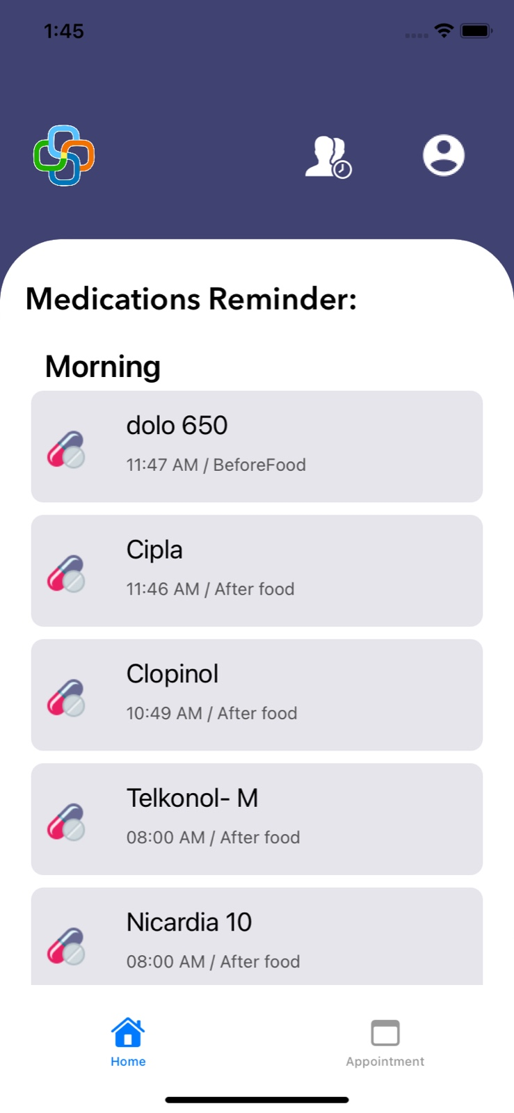
Fig. 1. displays the Medications screen of the Medication-Reminder application from patient login where the patient will have to view their Medications provided so that the doctor will be able to analyze the health status of the patients.

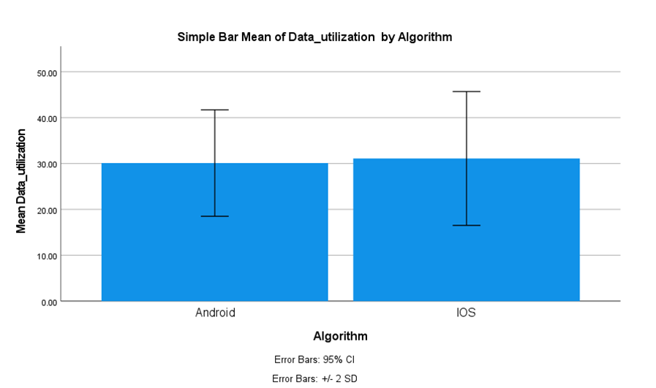
Fig. 2. When comparing the average Data Utilization of the two algorithms, the Android algorithm records an average Data Utilization of 28.17, while the iOS algorithm has an average Data Utilization of 33.83. The X-axis illustrates the iOS vs. Android Development methodology, while the Y-axis denotes the average Data Utilization. The error bar is represented as ±2 standard deviations.

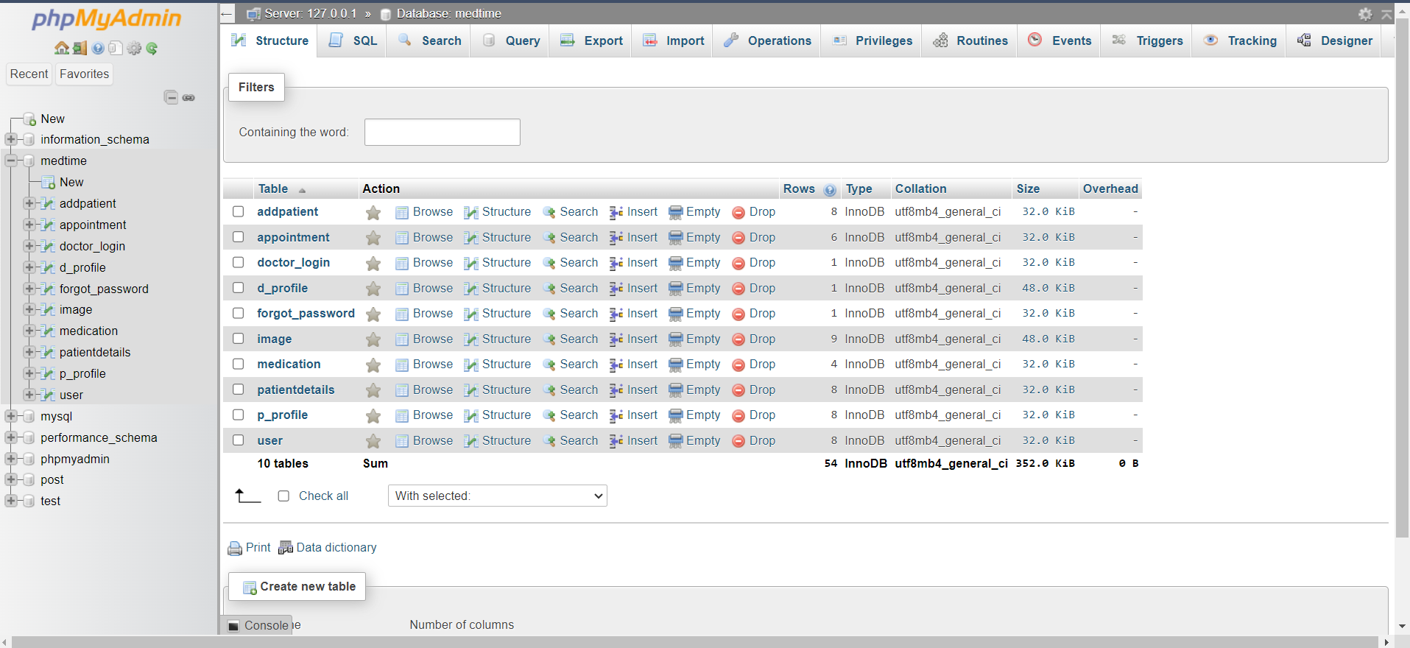
Fig. 3. The figure shows the database table of Medication-Reminder related to the patient details such as patient ID, patient password, patient name, patient contact, patient age, patient gender, patient Pressure, patient sugar level, Appointment status, and Prescribed Drugs. These details help doctors to know about the patient and his status of health.

